**Using cue scaffolding and perceptual learning in VR to train stereo-anomalous observers to rely on disparity cues**

Angelica Godinez1, Santiago M González2, Dennis M Levi1

1School of Optometry, University of California, Berkeley

2Construcción e Ingeniería de Fabricación, Universidad de Oviedo

Acknowledgements: This research was supported by The UC Berkeley, Chancellor and Regents Graduate Fellowship (AG), NIH training grant T32EY007043-40 (AG), UC Berkeley’s URAP stipend (ALK), grant R01EY020976 (DML) from the National Eye Institute and received mobility aid from the Universidad de Oviedo (SMG).

**ABSTRACT**

**Background:**

**Methods:**

**Results:**

**Discussion:**

**INTRODUCTION**

[Begin with the notion that we have a very rich sense of 3D in the world. That sense arises from a multitude of different visuals cues. Only some of these cues require stereopsis (depth from binocular disparity).]

Depth perception is a complex process where the brain integrates different visual cues [1]. Most of them require only one eye (monocular cues) and are categorized as psychological: overlapping (interposition), perspective (conical projection), lighting-shading, chromatic attenuation and focus are the most relevant. Accommodation is categorized as a physiological monocular cue. On the other hand, the binocular cues, convergence and retinal disparity, require both eyes. Retinal disparity or stereopsis arises from the concept of parallax: each eye perceives a slightly different image of the world that the brain must integrate in a single cyclopean perception [2]. Parallax is in the origin of a similar cue available to monocular vision, motion parallax, created by the relative motion between the user’s head and the perceived scene.

[Then introduce the idea of scaffolding]

Humans employ a statistically optimal strategy for combining depth cues within vision (Knill & Sanders, 2003; Hillis et al., 2004) and across different modalities (Ernst & Banks, 2002, van Beers et al., 2011). When sensory noise and cue conflict is relatively low, the optimal model is a linear weighted average of each cue, which aims at reducing variance (Ernst & Banks, 2002; Knilll & Sanders, 2003; Hillis et al., 2004). However, optimal integration seems to be adaptable and can be influenced through feedback (Jacobs & Fine, 1999; Ernst et al., 2000; Atkins et al., 2001), though feedback is not a requirement (Knill, 2007b). This reweighting of context-specific priors seems to be highly adaptable (Jacobson & Fine, 1999; Knill, 2007a; Knill, 2007b) and can occur at a relatively fast rate (vanBeers et al., 2011). Importantly, by pairing haptic feedback with binocular cues, observers can be trained to rely on binocular disparity cues (Ernst et al., 2000; Knill, 2007b; Vedamurthy et al., 2016).

[Then - why is stereopsis important?]

Stereopsis plays a key role in extracting depth information from natural scenes with binocular thresholds being a factor of 10 better than monocular thresholds (McKee & Taylor, 2010). In addition to the perceptual benefits, stereopsis also plays an important role in planning and executing everyday visuomotor tasks such as reaching and grasping (Meltmoth & Grant, 2006; Melmoth et at., 2009). However, abnormal visual experience during the “sensitive period” of development may result in amblyopia and, as a result, in reduced or absent stereopsis (Held et al., 1980; Petrig et al., 1981; Held, 1991; Birch & Petrig, 1996; Banks et al., 1975). Amblyopia, the leading cause of visual loss in children, is a neuro-developmental disorder that arises from an imbalance between the ocular inputs to the visual pathway (Hess et al., 2010; Li, Dumoulin, Mansouri, & Hess, 2007). It is characterized as reduced visual acuity in an otherwise normal eye despite best optical correction (Holmes & Clarke, 2006) and is typically secondary to misalignment of the visual axis (strabismus) and/or unequal refractive error (anisometropia). However, categorization of amblyopia based on etiology may be too restrictive (Maurer & McKee, 2016) since amblyopic deficit interactions are complex. Indeed, people with amblyopia experience sensory deficits, such as reduced visual acuity (Holmes & Clarke, 2006), contrast sensitivity (Hess & Howell, 1977; Levi & Harwerth, 1977; Levi, 1991) and positional acuity (CITE). In addition, they also experience higher-level deficits, such as crowding (Levi & Klein, 1985; Levi, 2008), motion perception deficit (Ho & Giaschi, 2007; Simmers et al., 2003; Mier et al., 2016), impaired contour integration (Levi et al., 2007), impaired visual decision-making (Farzin & Norcia, 2011), impaired visual attention (Hou et al., 2016) and, as said initially, poor stereopsis (Webber & Wood, 2005; Meltmoth et al., 2015; Levi, Knill, & Bavelier, 2015).

People who are stereo-blind or -anomalous exhibit deficits in depth perception, measurable for example in precision grasping (Grant et al., 2007; Melmoth et al., 2009), and particularly in the kinematic aspects that rely on visual feedback and online corrections (Meltmoth & Grant, 2006; Melmoth et at., 2009). Thus, for the overall well-being of people with amblyopia, stereopsis may be an important function to recover/ strengthen. Perceptual Learning, PL, defined as “any relatively permanent and consistent change in the perception of a stimulus array following practice or experience with this array (…)” [Gibson, 1963] has demonstrated great potential in amblyopia treatment [3]. Although functionally suppressed when viewing binocularly (Tavers, 1938; Birch, 2013), binocular stereovision mechanisms seem to be intact in people with amblyopia (Birch & Stager, 1985; Baker et al., 2007; Ding & Levi, 2014; Hess et al., 2014; Giaschi et al., 2013). Different visual stimuli have been evaluated to recover specifically stereoacuity when affected by amblyopia, from monocular training [ref] to dichoptic training [ref] and direct training [4] [5]. Interestingly, individuals with strabismic amblyopia have a very low probability of improvement with monocular training; however, they fare better with dichoptic training than monocular training, and even better with direct training (Levi et al., 2015). People with normal binocular vision can also benefit from training, improving their stereoacuity thresholds [6]. Moreover, training on demanding stereovision tasks improve stereoacuity in observers with normal vision even under natural (as opposite to laboratory) conditions. [7]

Considering that the main drawbacks of most laboratory-based training paradigms are user compliance, attention and motivation, several authors have proposed the use of specifically designed video games to treat amblyopia both in the clinic and as a home-based therapy strategy. Gamification, i.e. the use of game principles in non-game contexts, includes the use of levels of increasing difficulty adapted to participant performance, rewards, a story line, and social context, among other aspects [references]. The relatively new widespread use of cloud storage allows remote tracking of user compliance and incoming data. The ease of data monitoring has made remote therapy a viable and convenient option. Lack of compliance has been reported in studies conducted in the clinic while even using video games, stressing the importance of practitioner permanent supervision [8]. Several studies, including clinical trials (Gao et al., 20018), have reported benefits of using video games to treat amblyopia (Li et al., 2009; Li et al., 2011; Vedamurthy et al., 2015a; Vedamurthy et al., 2015b). Suppression, a hindrance to binocular function in amblyopia (Hess et al., 2010; Hess et al., 2014), seems to be responsive to video game play (Foss, 2017) and direct stimulation of stereopsis has been tested using this approach (Portela-Camino et al., 2018).

Recent commercialization of Virtual Reality head-mounted displays (VR-HMDs) have opened the opportunity to design therapies that incorporate gamification principles and build upon successful laboratory-based techniques such as PL and dichoptic training. VR-HMDs provide researchers and clinicians with the ability to present separate images to each eye, correct through software any misalignment due to strabismus without the need of a chin rest, and adjust contrast or luminance independently for each eye until balanced binocular vision is achieved. VR-HMDs provide a wide visual field, facilitating vergence in users with strabismus, and large disparities that may help in amblyopia treatment. Furthermore, VR-HMDs provide the ability for researchers to control depth cue content, with the exception of accommodation, which is the only cue without a commercial solution [9].

The aim of this paper was to train stereo-normal and stereo-anomalous participants to rely on disparity cues, by means of two VR games that combine demanding stereovision tasks, dichoptic PL and depth cue scaffolding.

**METHODS**

**Participants**

Twenty adults (mean age: 28 ± 2.5, range: 18 – 62 years, 14 female) with normal or corrected-to-normal vision and without ocular pathologies participated the study. Participants were recruited by telephone from the Meredith W. Morgan University Eye Center’s internal list of patients who gave written consent to be contacted for research studies and through internal UC Berkeley email list serves. The study protocol was approved by the Institutional Review Board of the University of California, Berkeley. Exclusion criteria for the study included: (1) ocular pathologies (e.g., macular abnormalities) or nystagmus, (2) non-concomitant or large angle constant strabismus (> 30 prism diopter), (3) inability to fuse, (4) constant esotropia (> 20 prism diopters), (5) visual acuity (VA) ≥ 20/200, and (6) dichoptic visual training of more than 10 hours.

**Study design and training**

All participants underwent a complete clinical assessment before and after the study (Figure 1). The complete clinical assessment included: (1) retinal health, (2) current prescription, (3) refraction at distance, (4) visual acuity, (5) ocular deviation (cover test), (6) binocular fusion (Worth Dot), and (7) clinical stereoacuity (Randot circles Stereotest® and Random Dot 3 Stereo Acuity Test with Lea Symbols®). Participants were categorized as anisometropic if there was a difference ≥ 0.50D in spherical equivalent refraction or ≥ 1.5D difference in astigmatism in any meridian, between the two eyes (Wallace et al., 2011). Participants were classified as strabismic in the presence of tropia with the cover test. Thus, five of the twenty participants were classified strabismic, four anisometropic, and eleven were classified as having normal binocular vision. Clinical details can be found in Table 1. Following the complete clinical assessment, eligible participants were placed in either the stereo-normal or stereo-anomalous group based on their initial Randot Circles Stereotest® stereoacuity measurement. Inclusion criteria for the stereo-anomalous group was baseline stereoacuity of 50 arc secs or worse. Within the stereo-anomalous group, there were four participants with anisometropia, four with strabismus, one with small-angle strabismus, and one stereo-weak but otherwise normal.

Figure 1. Study and training schematic. Each participant began with a complete clinical assessment. Followed by clinical and psychophysical stereoacuity tests. Participants then alternated between playing one of two games (Halloween or DartBoard) every 10 hours. After every 10 hours, clinical and psychophysical tests where administered again. Lastly, a complete clinical assessment was administered.

Training was organized in four blocks, each made up of ten 1-hour sessions. On each 10-hour block, one game of the two games designed specifically for this study was played: Halloween or DartBoard. Most participants completed 40 hours of training (4 blocks) with the exception of N2 and N4 who completed 20 hours, and S1, A1, N5, N8, N10, N11 who completed 50 hours total (Table 1).

To monitor participant progress, before and after each training block of 10 hours, participants completed both clinical and psychophysical stereoacuity tests. For clinical stereoacuity, we used the random-dot stereogram Randot Circles Stereotest® (RCS) and Random Dot 3 Stereo Acuity Test with Lea Symbols® (RD3). For psychophysical tests, we used the Pure Disparity Test (PDT) and dynamic random-dot stereogram (DRS) (for details see Ding & Levi, 2011). Both PDT and DRS stimuli were viewed through a stereoscope and presented on a Sony CRT monitor (CPD-G500) at a viewing distance of 68 cm from the participant.

Once the training was considered finished, the same initial complete clinical assessment was administered again.

**Games and apparatus**

We designed two video games (Halloween and DartBoard) to train stereovision. The games were presented in the Oculus Rift® Developer Kit (DK) 2, which is equipped with a gyroscope, accelerometer, and a magnetometer with an update rate of 1000 Hz. The Oculus Rift DK-2 has a resolution of 960 x 1080 for each eye, a field of view of 100 degrees, a refresh rate of 60-75 Hz, and a position tracking refresh rate of 60 Hz. To run the software, we used the Alienware AREA51R2 computer with Intel® Core™ i7-5820K CPU and an NVIDIA GeForce GTX 980 graphics card.

Importantly for participants who were unable to fuse the images (due to strabismus) and/or suppression, both games started with a high contrast fusion-lock frame presented to each eye, and a dichoptic nonius calibration. To correct for misalignment, the researcher manually adjusted the images presented to each eye (horizontal, vertical, and cyclo deviations, plus aniseikonia) until the participant reported complete alignment of the dichoptic cross (Figure 2- Top left). This step allowed us to correct for any deviation in subjective angle of squint. To minimize or eliminate suppression, image luminance (ranging from equal luminance between both images to complete occlusion of one eye) was adjusted for the dominant eye until the participant perceived equal luminance of the dichoptic lines crossing the reference frame.

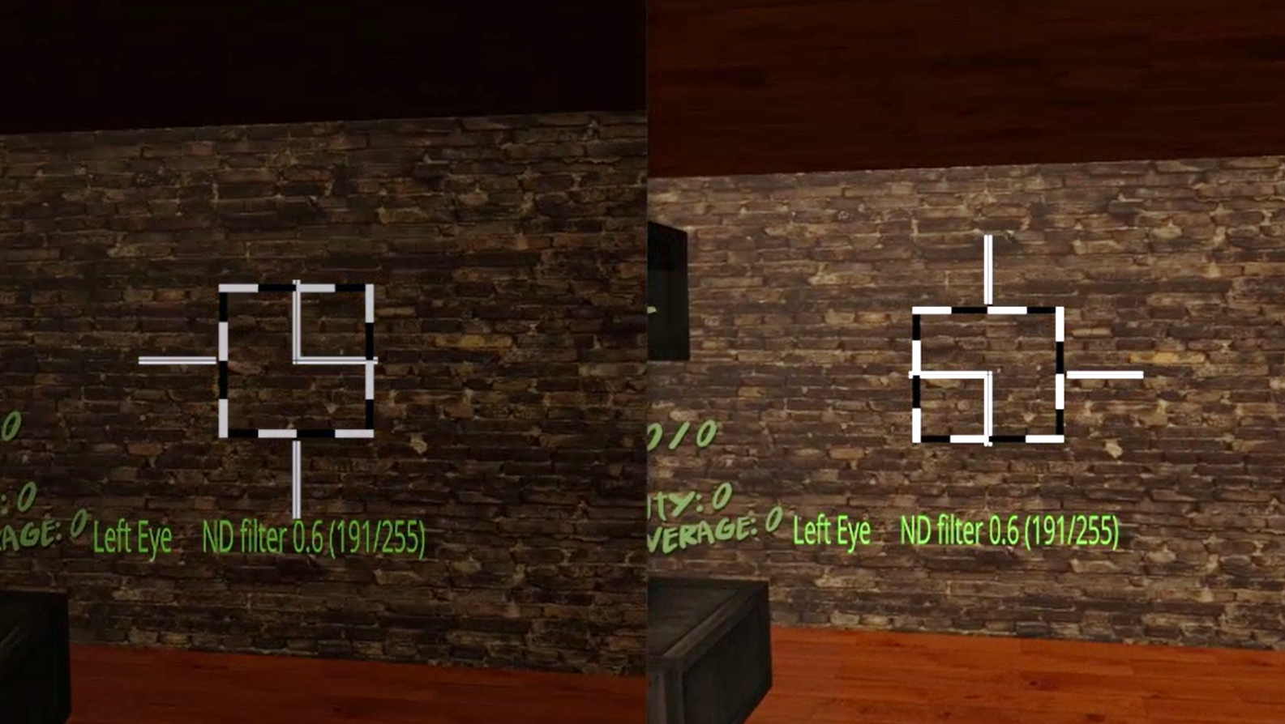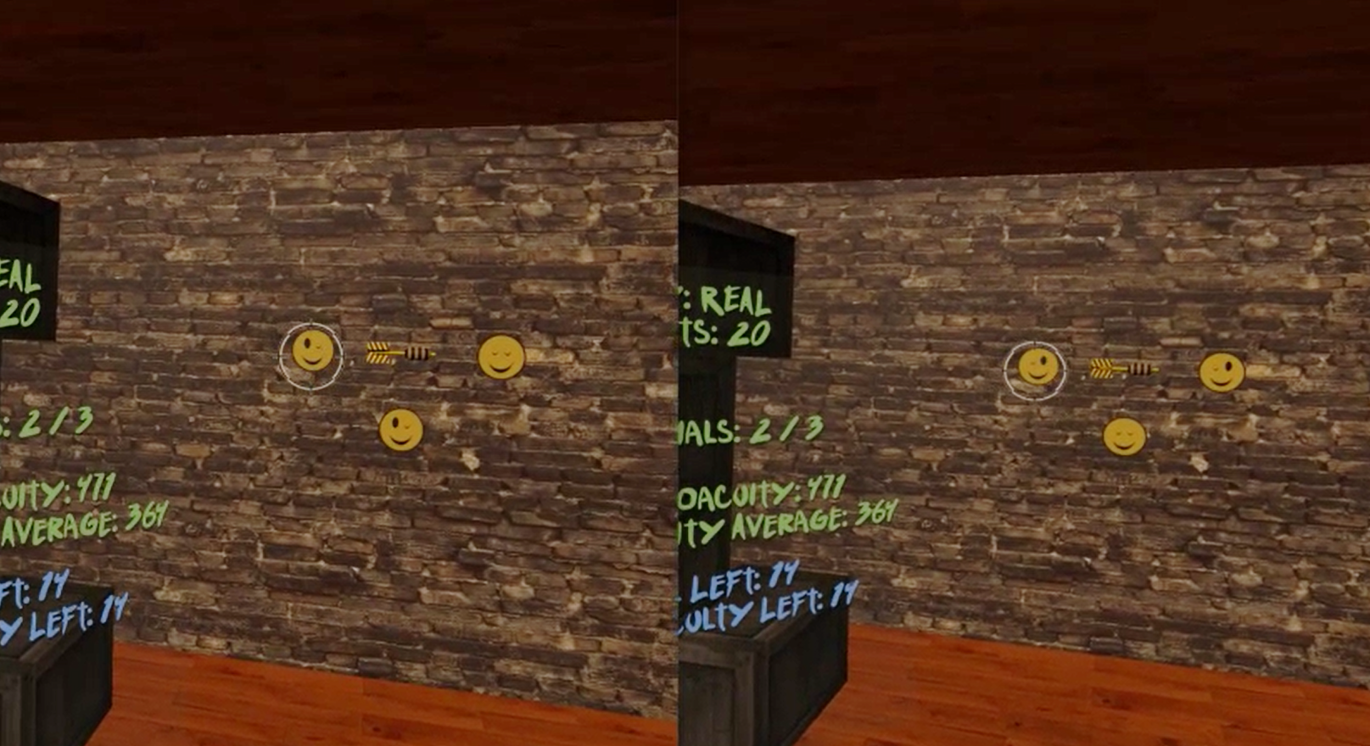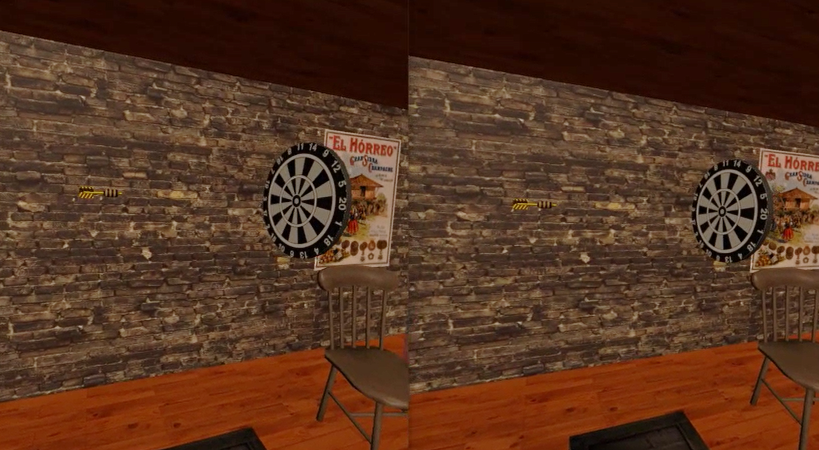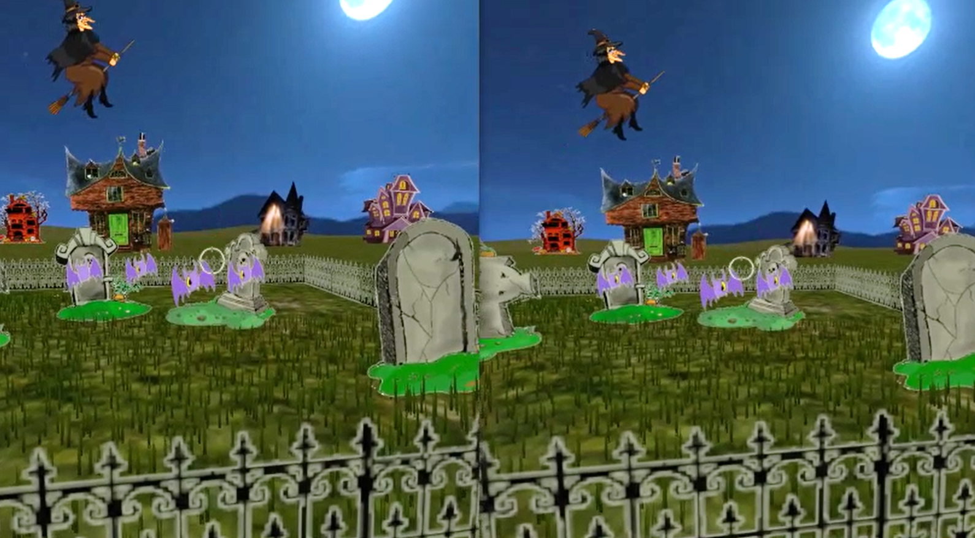

Figure 2. DartBoard and Halloween game screenshots. Top left: Fusion-lock frame calibration for DartBoard (same for Halloween, except the background) to eliminate subjective misalignment angles. Top right: DartBoard 3-AFC suppression test. Bottom left: Example of DartBoard trial. Bottom right: Example of Halloween trial.

Cue scaffolding was implemented in both games, creating three consecutive difficulty levels (Level 1, 2, and 3), which progressively eliminate non-stereoscopic depth cues, from an up-to-date VR scene (where accommodation is the only depth cue not simulated) to a scene where only retinal disparity was available. Each session began with Level 1, which consisted of monocular and binocular cues to depth including shadows, perspective, motion parallax, and binocular disparity. In Level 2, shadows were eliminated and perspective reduced- meaning, relative size was no longer a reliable cue (i.e., object size was not relative to object distance). Lastly, in Level 3, motion parallax was limited (only rotational movements of the head were allowed by the software), making binocular disparity the most helpful (almost unique) cue to calculate distance.

A 3-AFC suppression test (by means of dichoptic images) was also inserted in each games’ mechanics to help participants become aware of suppression episodes. For example, in the DartBoard game, participants were instructed to identify the smiley face in a set of three with both eyes open, which could only be seen if binocular fusion was maintained (Figure 2- Top right). In the Halloween game, participants were instructed to eliminate all targets with both eyes open and avoid targets with one eye, which again could only be achieved if binocular fusion was maintained. Importantly, the purpose of the suppression tests was to bring awareness of suppression to participants who actively suppressed. Suppression test failures were registered in both game result files.

Game mechanics and respective in-game measurements were different in each game. In DartBoard, participants were instructed to launch a dart, which was presented at the center of the screen, towards a dartboard that travelled from the back of the participant and moved towards the background of the scene (Figure 2- Bottom left). Movement of the dart once launched, was always linear and traveled from left to right, while movement of the board was linear, but not necessarily at a 90° angle or at the same speed of the dart. Both linear movements occurred in the same plane where the observers’ eyes were. Thus, there was no way of guessing the intersection of both trajectories using monocular cues. The movement of the dart board was designed to stop at intervals in order to facilitate the exercise. The perceptual learning task for the participant was estimating, using the background wall as reference, when the dart (stationary object) and the dart board (object moving in depth) were at the same distance (i.e. stereoacuity in-game measurement could theoretically be as low as zero arc secs). In Halloween, the participant was instructed to shoot the closest target in a variable set of targets (three to seven phantoms, pumpkins or vampires) as they approached the participant (Figure 2- Bottom right). Similar to the movement of the dart board, the approaching targets stopped at intervals to facilitate the exercise. Importantly, relative parallax between the targets were constant, and decreased across trials from 1000” to 400” over time, depending on the participants’ performance. Therefore, the perceptual learning task in Halloween was to determine the relative distance between several objects. It’s important to note that DartBoard in-game measurements result in stereoacuity threshold values for each one of the three levels; while Halloween in-game measurements result in the proportion of correct responses for each stereo demand at each level.

**RESULTS**

**Overall in-game performance**

* 1. DartBoard

To analyze the data and reduce bias, we took the log value of each stereoacuity threshold value per trial. We then performed a two-way between-subjects ANOVA on the in-game stereoacuity measures to examine the effect of group (stereo-normal and stereo-anomalous) and difficulty level (1, 2, and 3) on game performance. There was a significant interaction between group and difficulty level on in-game stereoacuity performance *F*(2, 102245) = 165, *p* < 0.001. Main effect analysis showed that the stereo-normal group achieved a lower threshold (Mean = 235” ± 164”) than the stereo-anomalous group (Mean = 291” ± 220”, *p* < 0.001) and performance scaled with difficulty level (*p* < 0.001). All participants showed an improvement in game performance as measured by the pre to post ratio (Figure 2).

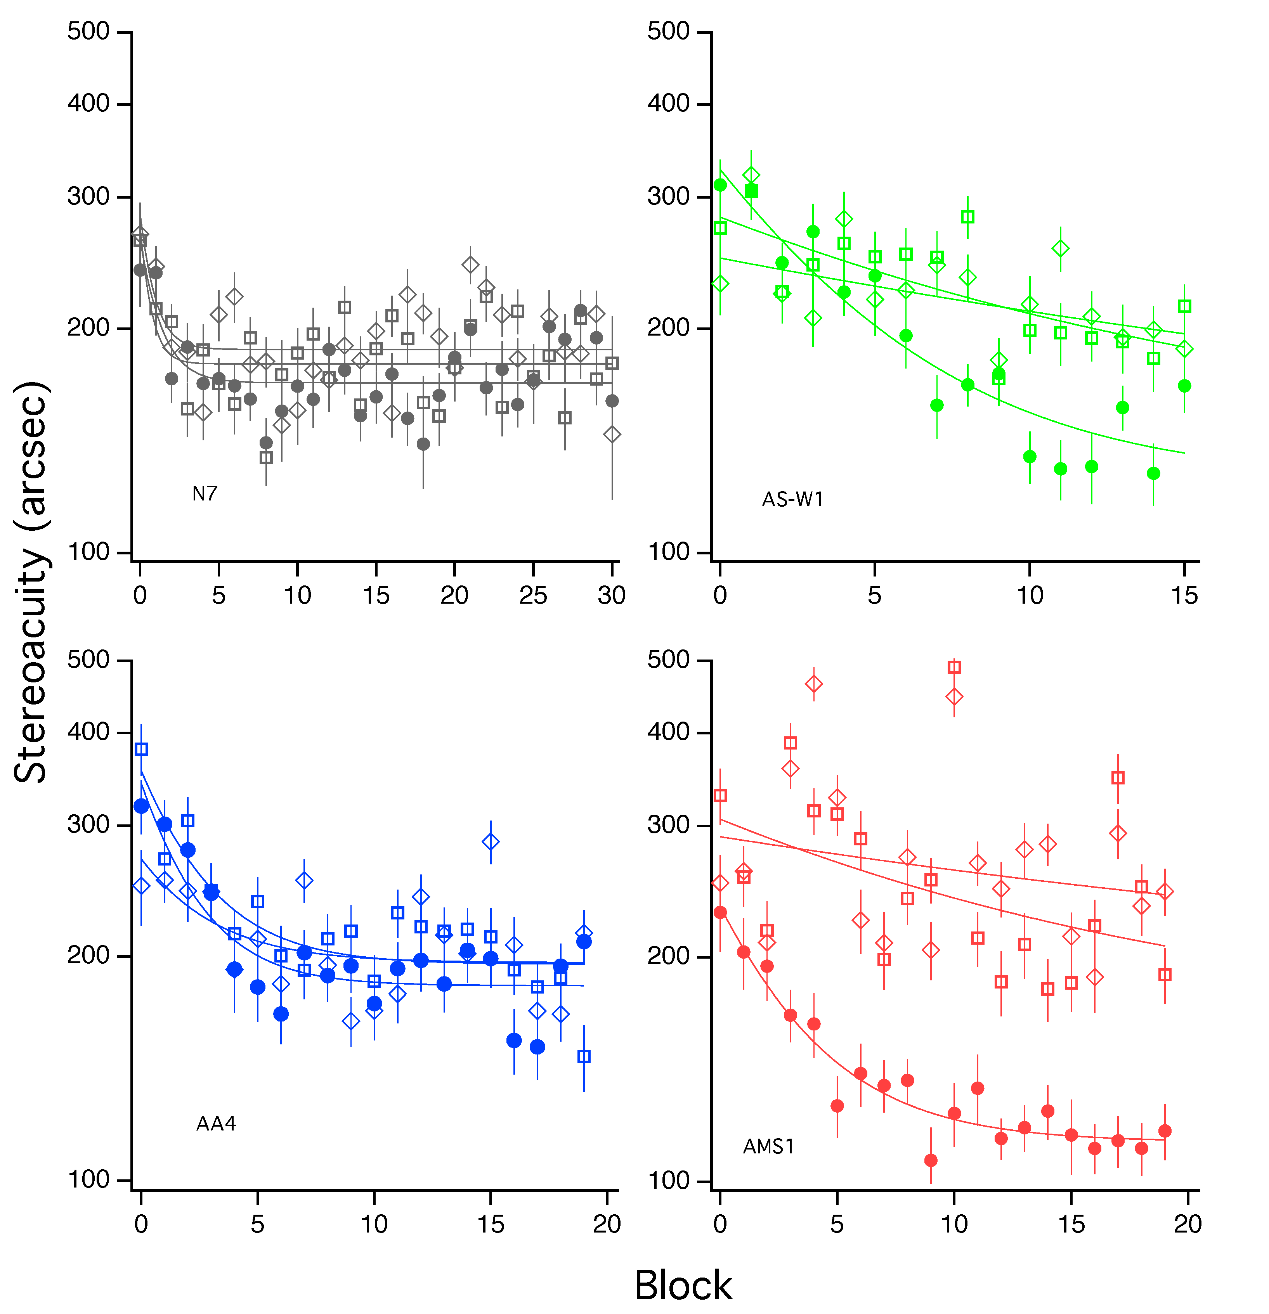

A.

B.

D.

C.

Figure 3. DartBoard in-game stereoacuity performance for (A) stereo-normal participant (N7), (B) stereo-weak, (C) anisometropic, and (D) strabismic participants. Level 1 is represented as solid circles, Level 2 as hollow squares and Level 3 as hollow diamonds.

To assess the amount and rate of learning in the DartBoard game, we fit the data of each participant and difficulty level with a three-parameter exponential function (Equation 1). From the fit, we calculated the asymptotic threshold, time constant, and the ratio of baseline to asymptotic threshold (PPR). The asymptotic threshold represents the best performance achieved through training. The time constant represents the time it took for the exponential to fall 37% (1/e) of the starting value. Thus, it represents the rate of learning. Lastly, the PPR represents the amount of learning as a factor of the starting threshold (higher PPR indicates greater learning).

Equation 1. $\left(PPR×e^{-\frac{\# of sessions}{Time constant}}+1\right)×asymptotic threshold$

We performed a two-way between-subjects ANOVA on the PPR to assess whether there was an effect of group or difficulty level on the amount of in-game learning. We found no significant effect of group *F*(1, 54) = 0.46, *p* = 0.5 or difficulty level *F*(2, 54) = 1.19, *p* = 0.31 on PPT.

A two-way between-subjects ANOVA on the asymptotic threshold (Figure 4) showed a significant effect of group *F*(1, 54) = 3.88, *p* = 0.05, with the stereo-normal group reaching a lower threshold on average (Mean = 168.48, SEM = 6.74) compared to the stereo-anomalous group (Mean = 192.15, SEM = 14.26). There was no significant effect of difficulty level on asymptotic threshold *F*(2, 54) = 1.05, *p* = 0.36.

Figure 4. Effect of group and difficulty on asymptotic threshold. Circles represent the asymptotic threshold of a single participant at each difficulty level. The horizontal line inside the box indicates the group median while the top and bottom lines represent interquartile ranges.

A two-way between-subjects ANOVA on the time constant (figure 4) showed a non-significant effect of group *F*(1, 54) = 1.06, *p* = 0.31 and a non-significant effect of difficulty *F*(2, 54) = 1.03, *p* = 0.36 on the time it took to reach the asymptote. Meaning, there was no significant difference in the rate of learning between groups and across difficulty level.

Our 3-AFC suppression test was presented at the beginning of each trial. The task was designed ensure that participants were not suppressing, and the trial did not begin until the participant accurately identified the dichoptic stimulus. Since there are three possible stimuli to choose from, we set three as the maximum number of dichoptic errors that could be made per trial. Anything above indicates a failure to do the task and is assigned a value of three.

To assess the if participants made fewer errors at the end of the study compared to the beginning, we calculated the error ratio by taking the sum of all errors for one participant across the three difficulty levels and dividing by the number of trials. We then, took the average of the first 4 sessions (eight blocks) and divided it by the average of the last 4 sessions. We found a moderate correlation of error ratio to PPR in the positive direction (give the r and p values) , indicating that participants who showed a greater ratio (made less errors at the end compared to the beginning) also showed a greater learning ratio (had a greater performance improvement in the game).

[Introduce quiver plot]

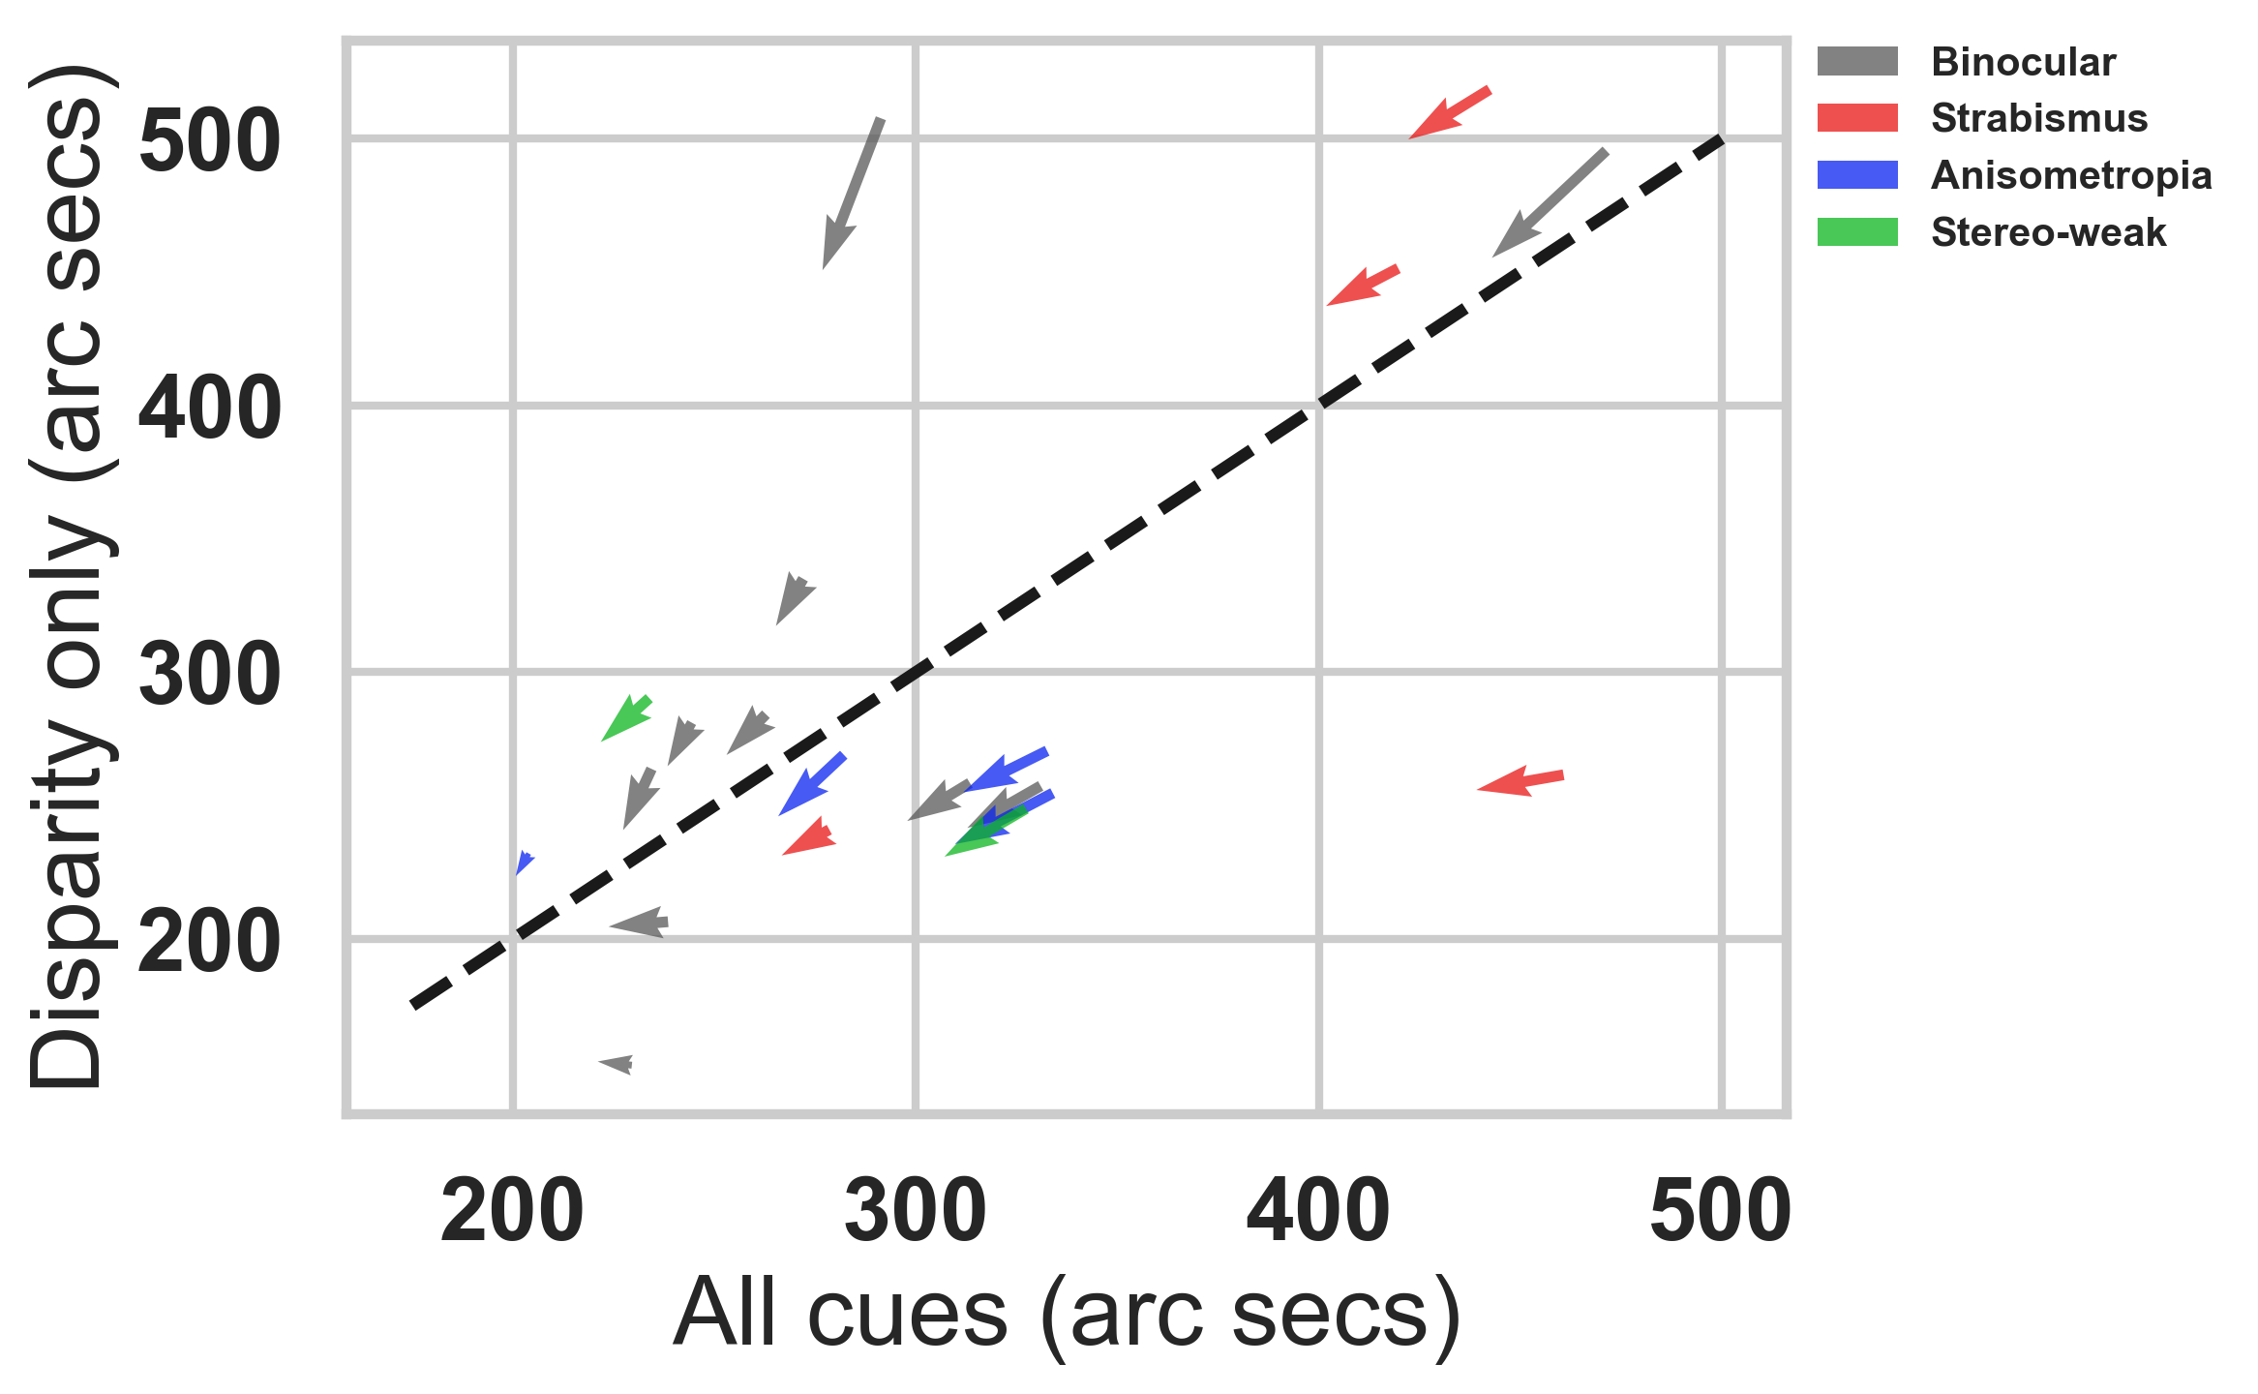QUIVER

Figure 5. Describe plot

1.2 Halloween

DESCRIBE WHAT IN-GAME STEROACUITY PERFORMANCE MEANS FOR HALLOWEEN

[Introduce figure 6]

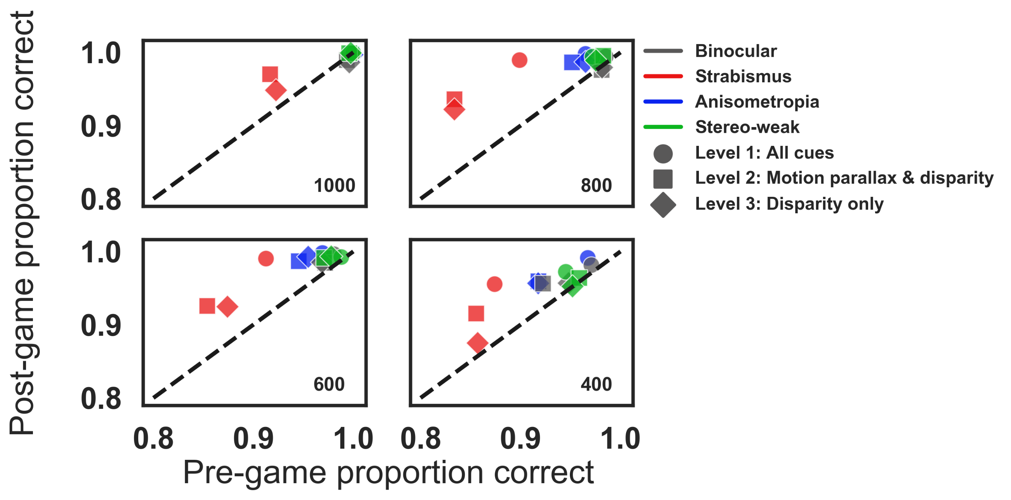

Figure 6. Halloween pre to post proportion correct for disparity values of 1000, 800, 600, and 400 arc seconds. Each symbol represents a different difficulty level for participants with anisometropia (blue), strabismus (red), stereo-weak (green), and normal binocular (grey). Points above the unity line indicate a reduction of errors in the last six blocks compared to the first six blocks.

**Changes in stereoacuity**

2.1. Transfer to clinical measures of stereoacuity.

All participants in the stereo-anomalous group (except AMS1) showed an improvement in the Randot Stereotest after training (Mean = 167” ± 266”) (Figure 7A- solid symbols). Notably, participant AS4 failed the Randot Stereotest before training and improved by 860”. Only participant AMS1 showed no transfer visual of stereoacuity in the Randot Stereotest with a consistent measurement of 70” before and after training. Seven out of the ten stereo-anomalous participants showed an improvement in the Random Dot 3 Stereo Acuity Test (Mean = 251” ± 433”). Three of the ten participants in the stereo-anomalous group (AS1, AS2, and AS4) failed the Randot3 test before training, but only AS4 improved after training (improved by 1400”). Stereo threshold for participant AMS1 was at 400” before and after training, while   
AS1 and AS2 failed the Random Dot 3 before and after training.

All participants in the stereo-normal group were at ceiling for both the Randot (20”) and the Random Dot 3 (12.5”) before training and remained at ceiling after training. Thus, their data is not shown in Figure 7 since it would fall on the unity line.

All four participants with anisometropia showed an improvement in Randot (Mean = 138” ± 162”) and Random Dot 3 (Mean = 264” ± 158”). Comparatively, all four participants with strabismus showed an improvement in Randot (Mean = 260” ± 402”), but only two (AS3 and AS4) showed an improvement in Random Dot 3 (Mean = 360” ± 963”). The stereo-anomalous participant classified as micro-strabismic (AMS1) did not show an improvement in Randot or Random Dot 3 after training, while the stereo-weak participant (AS-W1) improved by 80” in Randot and 12.5” in Random Dot 3.

To assess whether the initial stereo threshold gives an indication of future improvement, we calculated

Figure 7. Clinical stereoacuity improvement as a function of initial Randot and Random Dot 3 stereotests. Each symbol represents data from one participant in the stereo-anomalous group. Color indicates binocular condition: anisometropia (blue), strabismus (red), or weak stereo (green). (A) Shows a pre- versus post-training plot for Randot (solid symbols) and Random Dot 3 (open symbols) stereoacuity measures. Data under the diagonal unity line indicate an improvement in stereoacuity. (B) Shows the relationship between the initial stereo threshold and the pre to post stereo ratio. Data above the horizontal line indicate an improvement in stereo PPR.

A.

B.

stereo PPR by taking the initial stereo threshold and dividing it by the post stereo threshold (Figure 7B). Overall, participants with a higher (worse) initial stereo threshold as measured with Randot show a higher stereo PPR, meaning they improved more after training.

Participants were measured with the Randot and Random Dot 3 stereo tests at least five times with the exception of AS1, AA1, N5, N8, N10, and N11 who were measured seven times and N2 and N4 who only completed half of the study and were measured three times. Testing every ten hours allowed us to track clinical stereoacuity changes as a function of training hours. A Wilcoxon Signed-Ranks Test indicated that post clinical stereoacuity measures were lower after training compared to stereoacuity measures before training (Z = 0.0, *p* = 0.00043). (Figure 4). Participants with anisometropia reached a lower threshold (Randot mean = 138” ± 162”; Random Dot 3 mean = 264” ± 158”) at a faster rate (time constant) compared to participants with strabismus (Randot mean = 260” ± 402”; Random Dot 3 = 360” ± 963”, time constant).

To normalize stereo threshold across participants, we took each measured stereo threshold and divided by the highest score possible (20” for Randot and 12.5” for Random Dot 3). We then fit the data, collapsing across stereo tests, with an exponential fit (Equation 2) where y0, A, and tau are fit coefficients.

Equation 2. $Normalized stereo threshold=y0+A^{exp⁡(\frac{x - x0}{tau})}$

Participants with anisometropia show greater learning at a higher rate than participants with strabismus and weak-stereo (Figure 9).

2.2. Pyschophysical measures of stereoacuity.

All participants in the stereo-anomalous group, except for AA3 and AS2, showed an improvement in PDT (Mean = 169” ± 153”) (Figure 10). Participant AA3 and AS2 performed slightly worse after training compared to the initial PDT measurement by 7” and 67” respectively. Participants with strabismus showed a greater improvement (Mean = 193” ± 237”) compared to participants with anisometropia (Mean = 36” ± 51”). All participants in the stereo-normal group, except for N1, N10 and N11, showed an improvement in PDT (Mean = 16” ± 13”). The improvement was smaller compared to the stereo-anomalous group since most stereo-normal participants were close to celling.

The stereo-anomalous group had a greater improvement in RDS small (Mean = 395” ± 717”), medium (Mean = 160” ± 336”), and big (Mean = 539” ± 1255”) compared to the stereo-normal group who were close to celling at the beginning of training and showed only a small improvement (Mean = small: 4” ± 6”; medium: 2” ± 4”; big: 7” ± 11”). RDS improvement in the stereo-anomalous group was largely driven by participants with strabismus (Mean = small: 428” ± 477”; medium: 387” ± 472”; big: 1127” ± 1946”) compared to participants with anisometropia (Mean = small: 14” ± 17”; medium: 13” ± 13”; big: 215” ± 383”).



A.

B.

Figure 7. Psychophysical stereoacuity improvement as a function of initial stereo threshold. Each symbol represents a psychophysical test: PDT (triangle), RDS small (small circle), RDS medium (medium circle) and RDS big (big circle). Colors indicate binocular condition: anisometropia (blue), strabismus (red), stereo-weak (green), and normal stereo (grey). (A) Shows a pre- versus post-training plot. Data under the diagonal unity line indicate an improvement in stereoacuity. (B) Shows the relationship between initial stereo threshold and the amount of stereo improvement. Data above the horizontal line indicates an improvement in stereo.

Psychophysical tests were administered before, after every ten hours, and after the training. Thus, we were able to track psychophysical stereoacuity changes as a function of training hours. Similar to clinical measures of stereoacuity, Wilcoxon Signed-Rank Test indicated that post psychophysical stereoacuity measures were significantly different from stereoacuity measures before training (pre-test mean: ; post-test mean: ; Z = 39, *p* < 0001). Participants with anisometropia reached a lower threshold at a faster rate (time constant) compared to participants with strabismus (time constant).

We normalized psychophysical stereoacuity by dividing each measurement by the highest score possible. We then fit the data, collapsing across stereo tests, with an exponential fit (Equation 2). Similar to the clinical stereoacuity results, participants with anisometropia reached a lower threshold at a faster rate for RDS (Figure 11A) and PDT (Figure 11B).

**Changes in visual acuity**

In summary, our preliminary results show that most of the stereo deficient players improved in the game, and several showed transfer to both clinical (Randot®) and dynamic Random Dot Stereoacuity tests (Ding & Levi, 2011).

**Discussion.**

We conclude that consumer VR devices may provide a new tool for the recovery of stereopsis in adults with abnormal binocular vision.

**References.**

[1] Swanston, M. T., & Wade, N. J. (2001). Visual perception: An introduction. Psychology Pres

[2] Wheatstone, C. , 1838 “Contributions to the physiology of vision—Part the first. On some remarkable, and hitherto unobserved, phenomena of binocular vision” Philosophical Transactions of the Royal Society of London 128 371–394

[3] Dennis M. Levi, Roger W. Li Perceptual learning as a potential treatment for amblyopia: A mini-review. Vision Research 49 (2009) 2535–2549

[4] Jian Dinga and Dennis M. Levia, Recovery of stereopsis through perceptual learning in human adults with abnormal binocular vision, PNAS September 13, 2011 108 (37) E733-E741; <https://doi.org/10.1073/pnas.1105183108>

[5] Portela et al. A Random Dot Computer Video Game Improves Stereopsis, Optom Vis Sci. 2018 Jun;95(6):523-535

[6] Schoemann, Micha Daniel et al. Repetitive dynamic stereo test improved processing time in young athletes, Restorative Neurology and Neuroscience, vol. 35, no. 4, pp. 413-421, 2017

[7] Adrien Chopin, Dennis M. Levi & Daphné Bavelier. Dressmakers show enhanced stereoscopic vision. Scientific Reports volume 7, Article number: 3435 (2017)

[8] Jonathan M. Holmes et al. Effect of a Binocular iPad Game vs Part-time Patching in Children Aged 5 to 12 Years With Amblyopia. A Randomized Clinical Trial. JAMA Ophthalmol. 2016 Dec 1;134(12):1391-1400. doi: 10.1001/jamaophthalmol.2016.4262.

[9] Gordon D. Love et al. High-speed switchable lens enables the development of a volumetric stereoscopic display. 2009 / Vol. 17, No. 18 / OPTICS EXPRESS 15716

This research was supported by grant RO1EY020976 from the National Eye Institute (DML), the University of California Chancellor’s Fellowship (AG), and received mobility aid from the Universidad de Oviedo (SMG).